Metoda pentru counter pasi si calculul distante si vitezei in alergare.

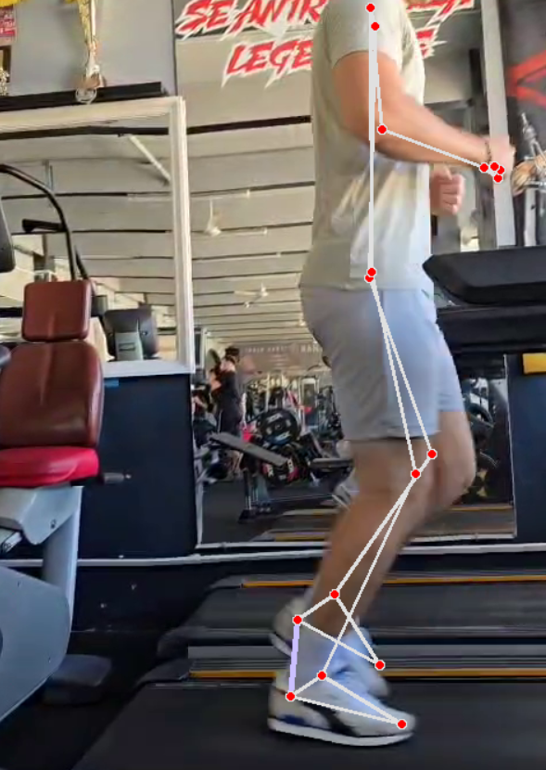 | 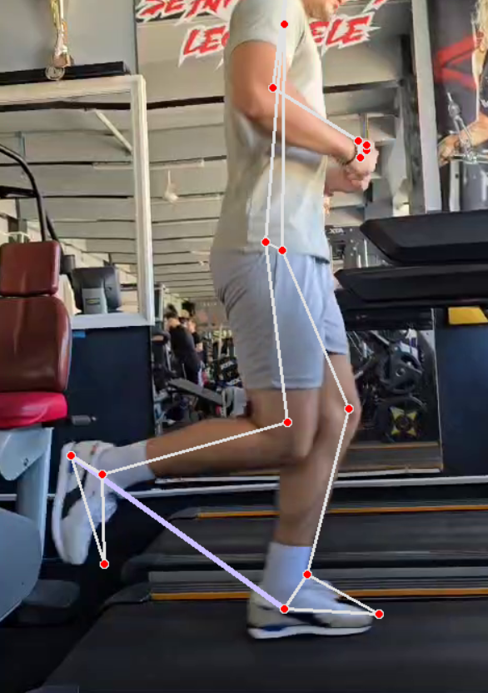
Algoritm folosit pentru keypoints:
- mediapipe
Metoda pentru numarat masi:
Pentru contorizarea numarului de pasi, este verificata distanta dintre cele 2 calcaie in timpul alergarii.
- In momentul in care distanta dintre acestea creste, variabila self.in_pas este setata pe “True”, ceea ce inseamna ca se asteapta a se realiza un pas oricand in urmatorul frame.
- Atunci cand distanta dintre calcaie scade, pasul se considera a fi realizat (self.in_pas devine “Fals" iar self.count creste cu 1).

Calculul distantei parcurse si al vitezei:
Sursa1: “Average Stride Length by Height
When you use your height to determine your stride length, you get a rough estimate that isn't personalized. But if you're wondering how long your stride length should be, or the normal step length for your height, there is a way to measure and estimate. It can be useful to check your results by the other methods. It is the method used in the automatic settings of many pedometers and activity trackers:
Females: Height in inches multiplied by 0.413 equals stride length
Males: Height in inches multiplied by 0.415 equals stride length”
Sursa: https://www.verywellfit.com/set-pedometer-better-accuracy-3432895
Sursa2: “Another fruitful measure which has been used within the forensic field to predict stature is stride length. Studies have shown that the stride length divided by stature is within the range of approximately 0.41 to 0.45.⁷ A mean working ratio for female subjects is 0.413, whilst a working ratio of 0.415 can be used for male subjects,⁵ however, in reality, there is variation across a population.”
Sursa: https://www.sciencedirect.com/science/article/pii/S1752928X17301208
Sursa3: “All individual assessments for both in‐person and remote visits were scored 0 to 4 (with higher scores indicating higher levels of physical performance), based on the cutoffs from the SPPB (7); the overall score was the sum of the three individual scores (range, 0‐12). For remote visit gait speed, walk‐in‐place steps were converted to distance walked using the conversions 0.413*(height in meters) for female participants and 0.415*(height in meters) for male participants (8). Gait speed for the remote visits was then estimated as (estimated distance in meters)/(60 seconds).”
Sursa: https://pmc.ncbi.nlm.nih.gov/articles/PMC10502850

Distanta parcursa se calculeza in functie de sursele citate mai sus. Se inulteste in functie de genul atletului, un indice, cu pasii facuti in videoclip si rezulta distanta pe care atletul a facut-o.
Viteza instantanee o calculez realizand un raport intre distanta din momentul respectiv al videoclipului si timpul din videoclip in care se realizeaza calculul.
#TO DO: calculul acceleratiei

def calculateDistanceAndSpeed(self):
#I found in the specialized documentation a ratio between height and step distance
#Females: Height in inches multiplied by 0.413 equals stride length
#Males: Height in inches multiplied by 0.415 equals stride length
if self.athleteGender == "M":
self.distance = 0.415 * self.athleteHeight * self.counter
elif self.athleteGender == "F":
self.distance = 0.413 * self.athleteHeight * self.counter
#I calculated the duration at which a frame is processed, to obtain the instantaneous speed
fps = self.cap.get(cv2.CAP_PROP_FPS)
frame_time = 1 / fps
self.video_timer += frame_time
#Speed
self.speed = self.distance / self.video_timer

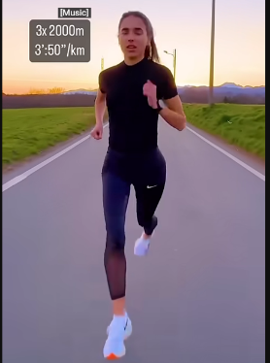
Vulnerabilitati:
- Conteaza unghiul de filmare:
O astfel de filmare cu fata la camera impiedica calcularea corecta a pasilor.
Rezolvare: impunerea filmarii dintr-o anumita perspectiva

Rezultate:
